**Name:** Om Raut

**Designation-** Devops Engineer

**Task 4 Report – Docker Compose (Multi-Container App on EC2)**

**Objective**

Deploy a **multi-container application** (Node.js + MongoDB) on an **EC2 Ubuntu instance** using **Docker Compose**.

**Steps Performed**

**1. Connect to EC2 Instance**

* Used SSH to connect to the EC2 server.

ssh -i "ec2-server.pem" ubuntu@<EC2-Public-IP>

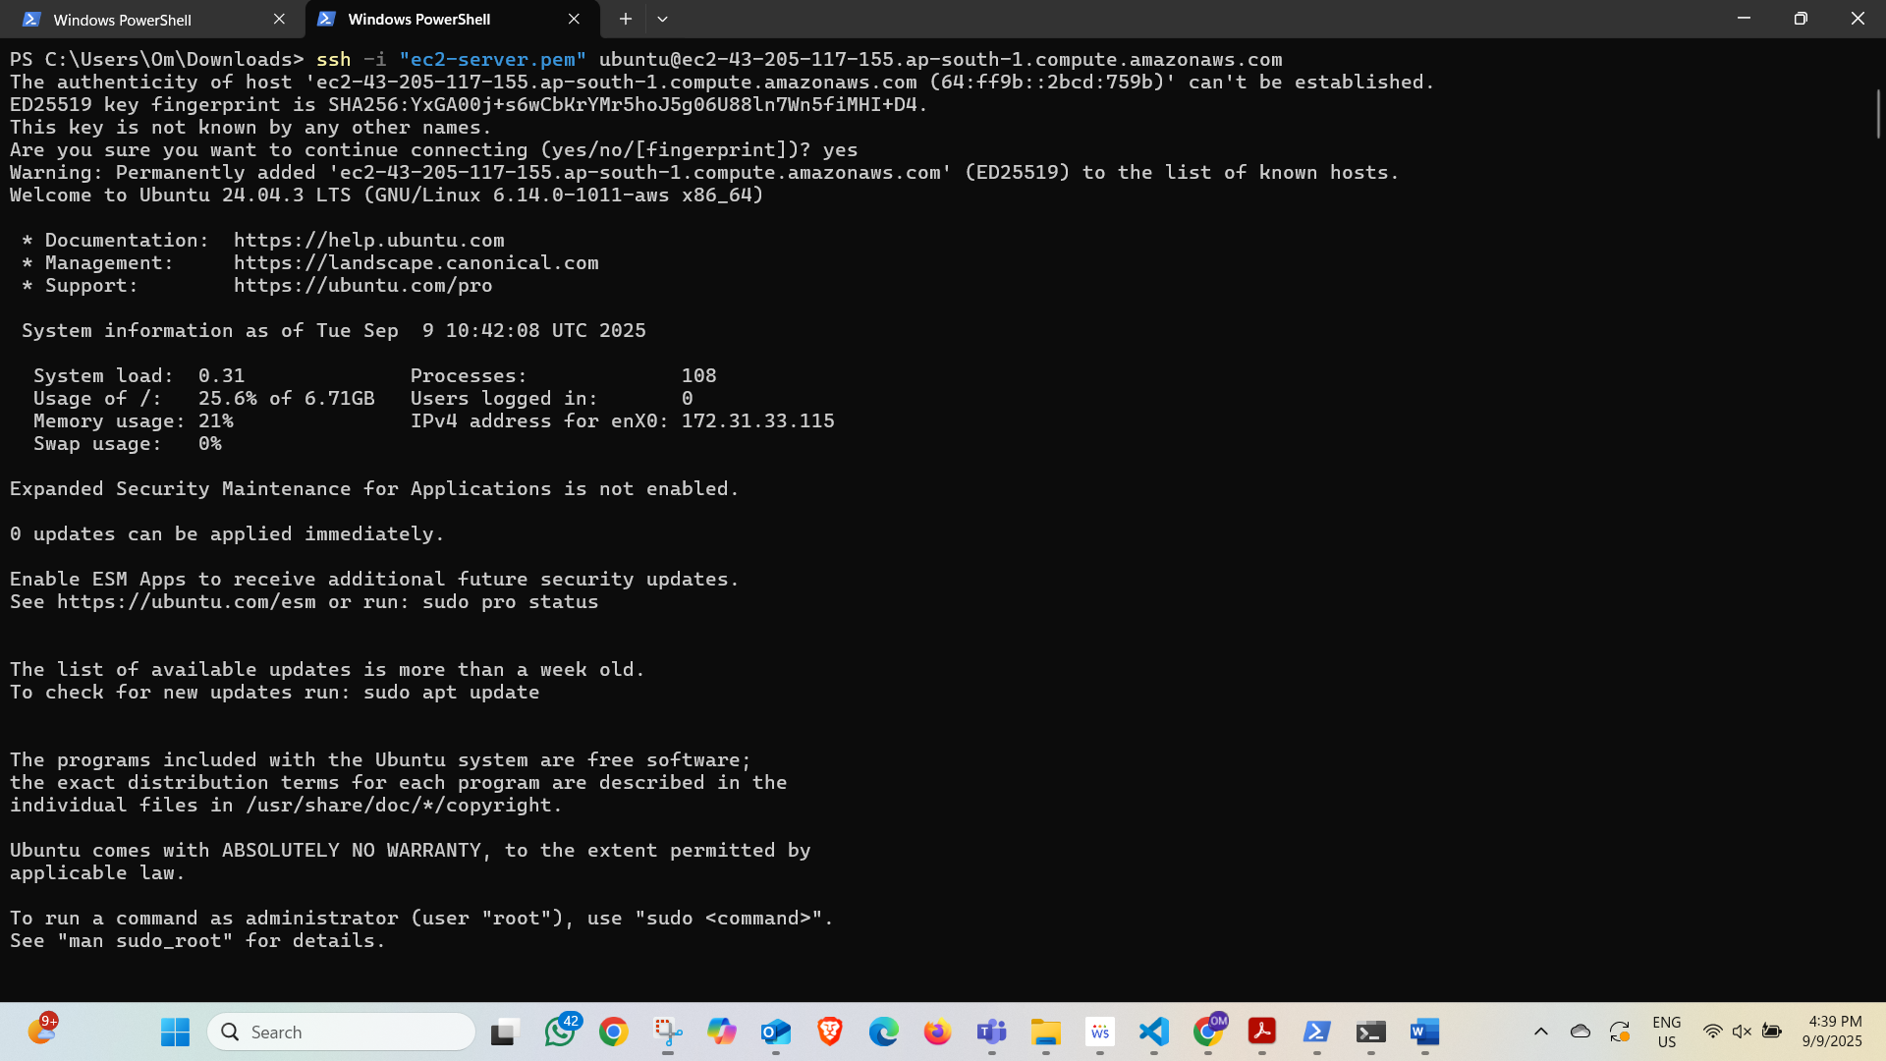

**2. Installed Docker & Docker Compose**

* Installed Docker engine and Docker Compose on the EC2 instance.

sudo apt update sudo apt install docker.io docker-compose -y

* Verified installation:

docker --version docker-compose --version

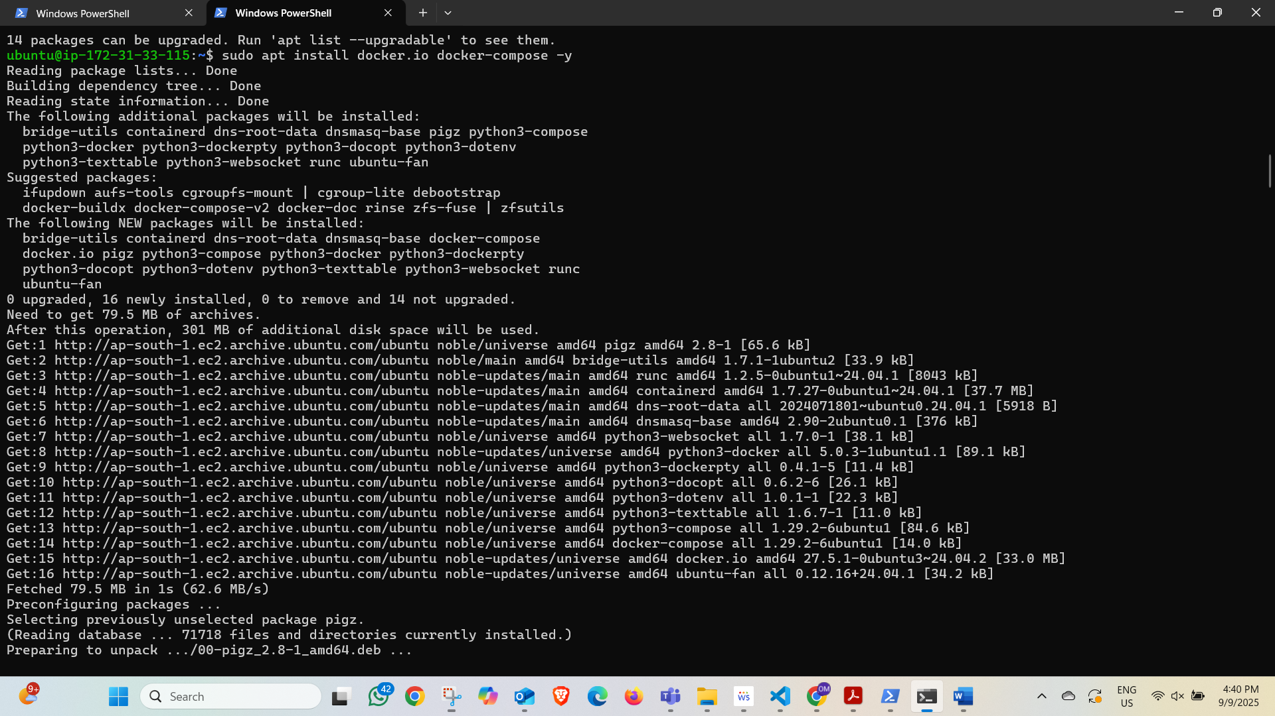

**3. Created Application Files**

Inside the EC2 instance project folder docker-compose-task:

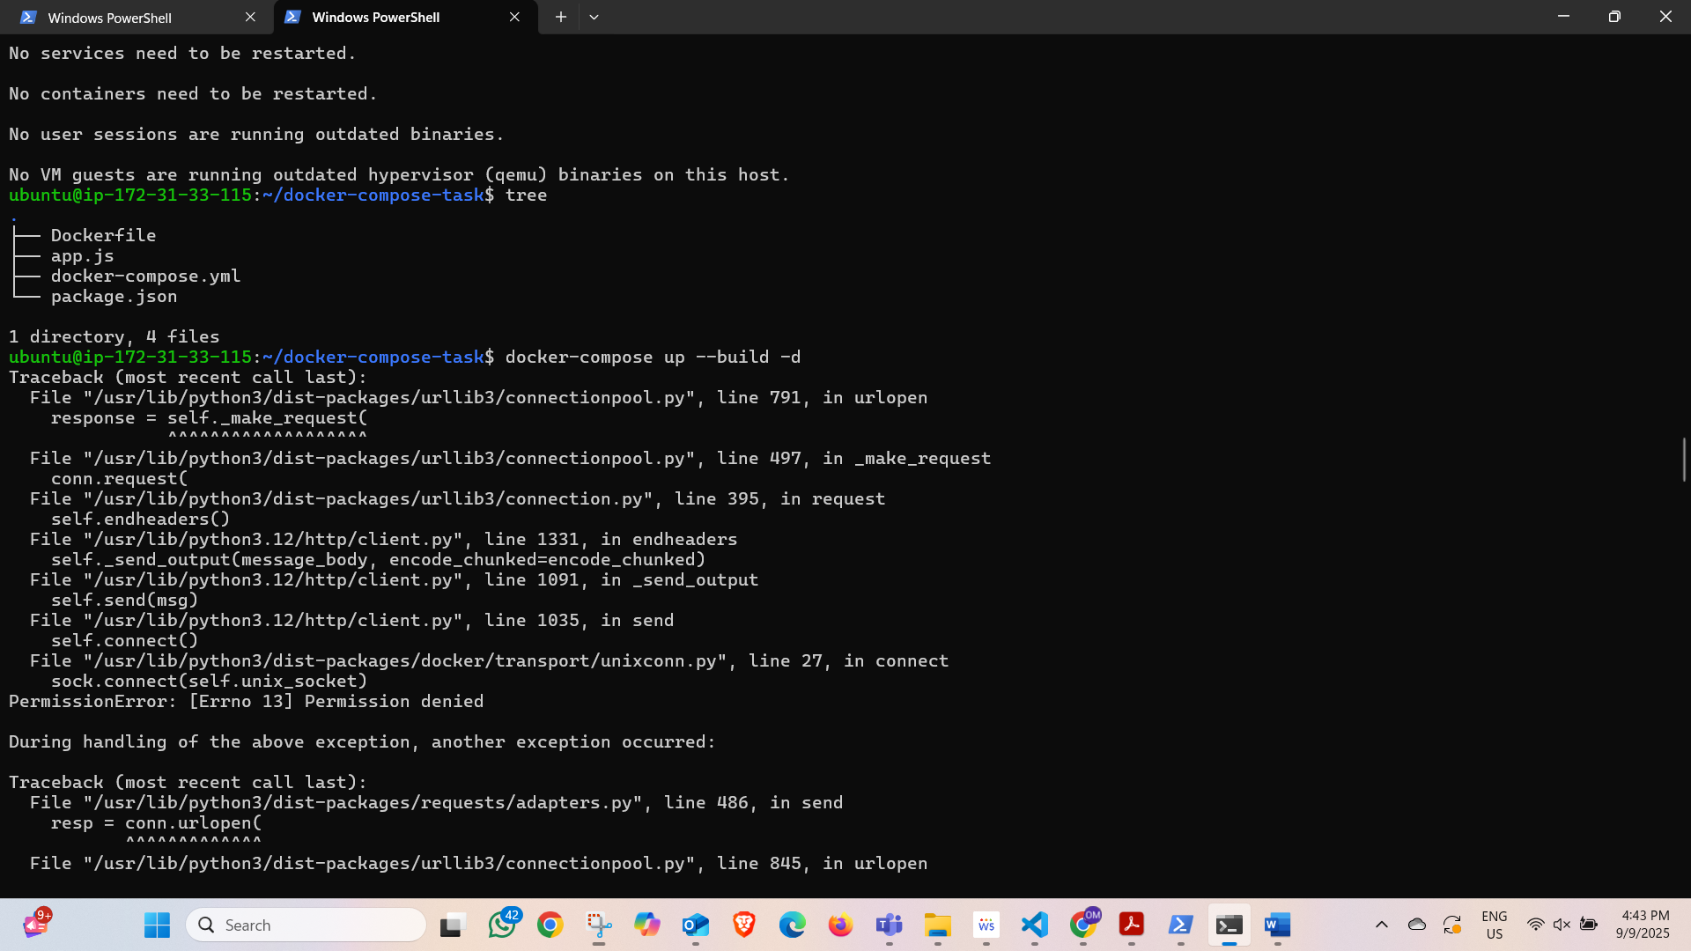

**4. Started Containers with Docker Compose**

sudo docker-compose up -d

* Verified containers:

docker ps

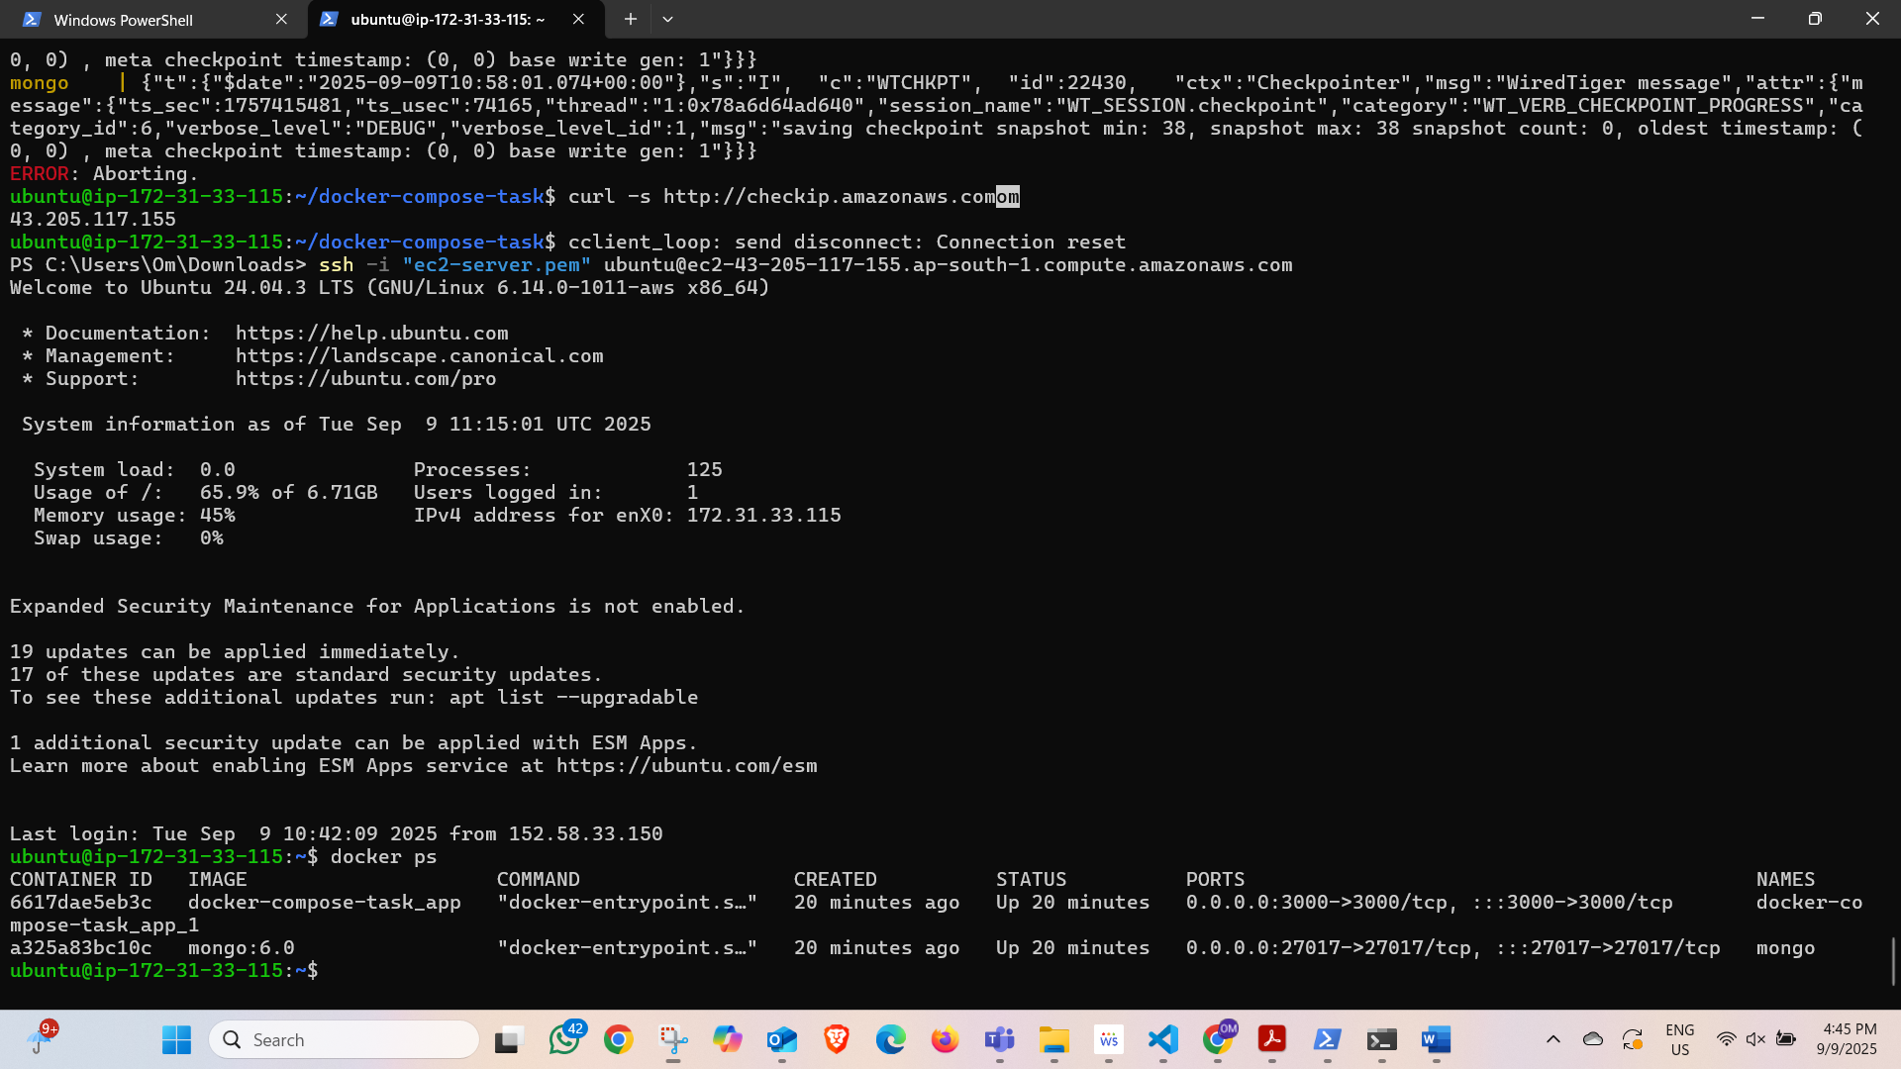

**5. Application Testing**

* Retrieved EC2 public IP:

curl -s http://checkip.amazonaws.com

* Accessed app in browser:

http:*//<EC2-Public-IP>:3000*

✅ Output:  
Hello from Node.js + MongoDB on EC2 with Docker Compose!

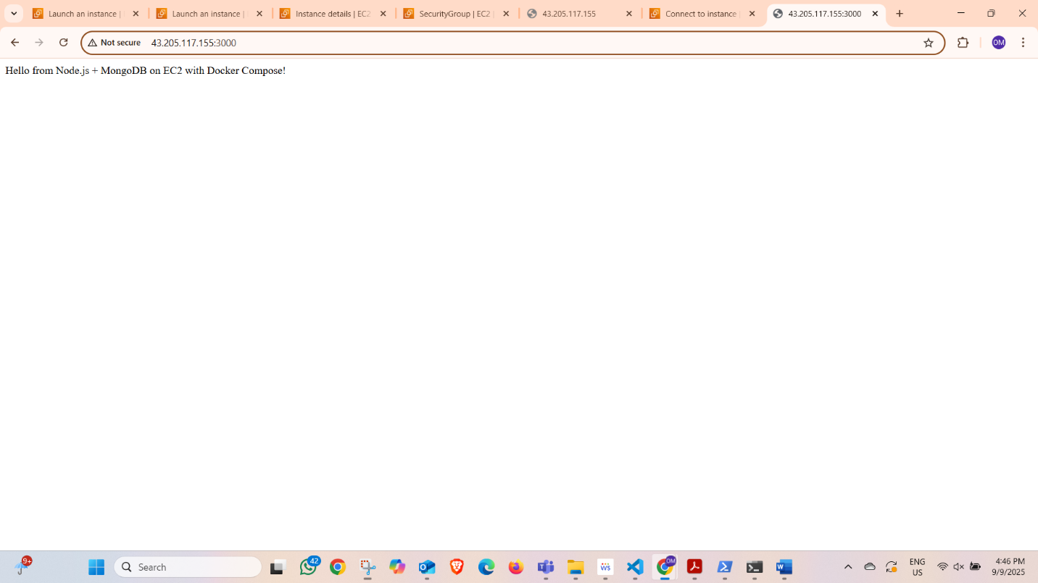

**Result**

Successfully deployed a **multi-container application (Node.js + MongoDB)** on **AWS EC2 using Docker Compose**.

* Node.js app connected to MongoDB inside Docker network.
* App accessible publicly via port 3000.